Withdraw models and notes
Bill Prisbrey
2025-12-04
PURPOSE: The purpose of this report is to explore ‘Withdraw’ grades using different predictive models.

Executive Summary
This report finds that “Withdraw” grades are a rare phenomenon with essentially no relationship to pre-admit data.
Predictive model accuracy is essentially random.
ver | Description | Kappa | Notes
vA0 | Admissions data | 0.025 | 'propensity to withdraw' is not found in admit data
vB0 | Adds credit load | 0.037 | suggests concurrent information is slightly more important
vC0 | Adds GPA prediction | 0.029 | 'pred' is new top variable; suggests data leak
vD0 | Rolling GPA prediction | 0.016 | rolling prediction eliminates leak; still no accuracy

Discussion
Kappa values of <0.05 suggest that the propensity to withdraw is simply not found in data available at the time of admission. In other words, the ACT test doesn’t have a ‘propensity to withdraw’ section.
Adding the concurrent credit load improved the Kappa. It’s so low it might just be random noise. Or, it might be a suggestion that concurrent, contemporaneous, or situational information might be more predictive of a withdraw than admit-level data.
Adding the GPA prediction resulted in that prediction becoming the new top variable, but the accuracy dropped. Again, the values are so low it could just be noise. Or, it could be a data leak in that I applied the prediction to the same data that I trained on.
Substituting a rolling GPA prediction to eliminate a data leak resulted in an even lower Kappa. (However, a closer investigation revealed a discontinuity between prior years and year 2024. This was significant at the p<.1 level per a logistic regression model. This is a whisper that there might be a detectable relationship between ‘W’ and predicted grades going forward, or it might be more noise.)
The fact that the admissions data was able to predict grades with some accuracy, but couldn’t distinguish withdrawals, suggests that withdraws operate by an entirely different mechanism. The addition of predicted grades without improving the model adds evidence to this conclusion.
It is worthy of its own investigation as a separate project to brainstorm drivers and seek new data sets.
Potential causes and underlying factors of withdrawals may include things like:
- Behavioral tendencies, where some students have personality traits that might more accurately predict a ‘W’.
- Difficulty adjusting to university-level studies.
- Personal preference for an instructional style or a personality match between instructor and student.
- Completely external to the academic experience, such as a medical, family, or financial difficulty.
- Schedule difficulties unrelated to academic abilities may precipitate a withdrawal.
New data sets could include:
- Early grades for homework, quizzes, and tests.
- Schedule to determine potential conflicts.
With the ‘admit-level’ information used in these models, and the predicted grade in vD0, it does not seem that ‘withdraw’ students are adjacent to flunking students, or related to the expected grade at all, otherwise the models would be more accurate.
A few avenues I would like to investigate includes:
- Match: Is a student more likely to withdraw from a math course not appropriate to their abilities?
  - Use the model to predict an expected grade, and incorporate that as a prediction variable. Lower expected grades should have higher withdraw rates.
  - Develop counterfactuals and rank the courses. The lower rankings (lower expected GPA) should have higher withdraw rates.
  - Develop a ‘difficulty’ ranking of the courses and use as a predictive variable.
  - Use the catalog number itself as a difficulty ranking
- Result of investigating match (vD0): Version D0 used a rolling prediction of grade based on prior years to avoid a data leak. Kappa was still very low. This suggests that withdrawals are unrelated to academic ability and that the alternative approaches described above should be pursued.
  - However, it is worth noting that the year 2024 saw an improvement in the relationship to predicted grades to a significance of p < .1. An investigation of the distribution saw that higher grades were actually more likely to withdraw. A possible explanation is that in 2024, students who submitted ACT math scores are more elite and therefore more cautious of their grades. If these students were anticipating a “B” instead of an “A” then they might withdraw. Or in other words, the behavior of the subset of students used in this model for 2024 actually do have a relationship to predicted grades and are different than the behavior of the general population from years prior.
Because vD0 failed to improve Kappa, a separate project is suggested.

Next steps
- Abandon using the current approach of admit-level data and pursue a separate project as described above.
Possible steps if continuing the current approach of using admit- and course- level data:
- Create a rolling prediction of GPA values from models trained on the prior data. DONE
- Rank the counterfactual GPA’s per student and use as a variable.
- Approximate course difficulty
  - With the catalog number
  - With a novel approach (by developing the ‘gentle guidelines’ suggested by the predictive models)

APPENDIX

Withdraw is rare or highly imbalanced
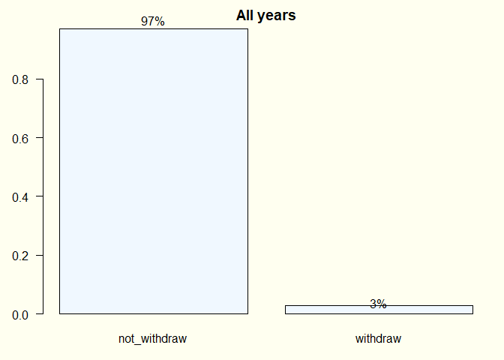

Withdraw does not appear related to expected grades
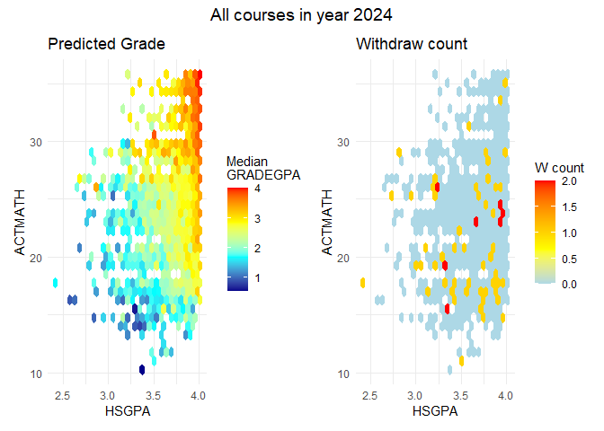

Withdraw may be slightly related to expected grades
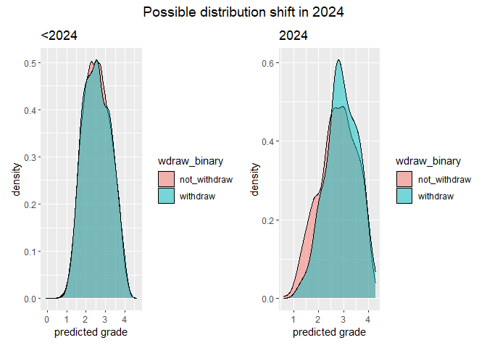

vA0 predictors
x
course
SEX
FIRST_GEN_STATUS_CD
ETHNICITY
RESSTAT
FA_PELL
APCREDIT
HSGPA
HSPRIVATE
HONORS
ACTCOMP
ACTENGL
ACTMATH
ACTSCI
cohort_year
class_year
yr_diff
season
course_level
vol_cluster
age_cut

vB0 predictors
Add “load” as the number of credits taken

vC0 predictors
Add “pred” as the predicted GPA from a model trained on years less than or equal to 2023, and applied to all years.

vD0 predictors
Substitute “pred” as the predicted GPA from rolling models trained on years prior to the year predicted.

